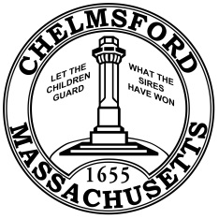

Agricultural Commission

Notice of Public Meeting

Email Posting to townclerk@chelmsfordma.gov Thank you.

As required by G.L. c. 30 A, §18-25

Filed with Town Clerk:
RECEIVED
2026-02-11
10:33 AM

TOWN OF CHELMSFORD
PATRICIA E. DZURIS
TOWN CLERK

DATE: February 18, 2026 TIME: 7:00 PM

PLACE: Town Hall ADDRESS: 50 Billerica Rd ROOM: 206

AGENDA

Filling the current vacancy on the Commission – Caroline has applied

Approval of minutes.

Right to Farm signage.

Taking a role to support non-commercial agriculture.

Jaimie’s concerns with the Town and the Sunny Meadow leases

Any other new business

Agenda for and scheduling of the next meeting.

